Experiment 10: Install and Explore Selenium for automated testing

AIM: Install and Explore Selenium for automated testing

DESCRIPTION:
To install and explore Selenium for automated testing, you can follow these steps:

Install Java Development Kit (JDK):
• Selenium is written in Java, so you’ll need to install JDK in order to run it. You can download and install JDK from the official Oracle website. (Or) Open Terminal and Install OpenJDK 21 on Ubuntu with
$ sudo apt install openjdk-21-jdk -y

• Install the Selenium WebDriver:
You can download the latest version of the Selenium WebDriver from the Selenium website. You’ll also need to download the appropriate driver for your web browser of choice (e.g. Geckodriver for Mozilla Firefox).
https://www.selenium.dev/downloads/ and Download selenium-java-4.48.0.zip

.Download the GeckoDriver:
https://github.com/mozilla/geckodriver/releases and Download geckodriver-v0.37.1-linux64.tar.gz

Open Terminal and change the Directory to Downloads

$ cd Downloads/

$ sudo apt install unzip

$ tar -xvzf geckodriver-v0.37.1-linux64.tar.gz

geckodriver

$ unzip selenium-java-4.48.0.zip -d selenium
Install an Integrated Development Environment (IDE):

• To write and run Selenium tests, you’ll need an IDE. Some popular choices
include Eclipse, IntelliJ IDEA, and Visual Studio Code.
Open Visual Studio Code and Go to Extensions search Java extension pack and
install it.

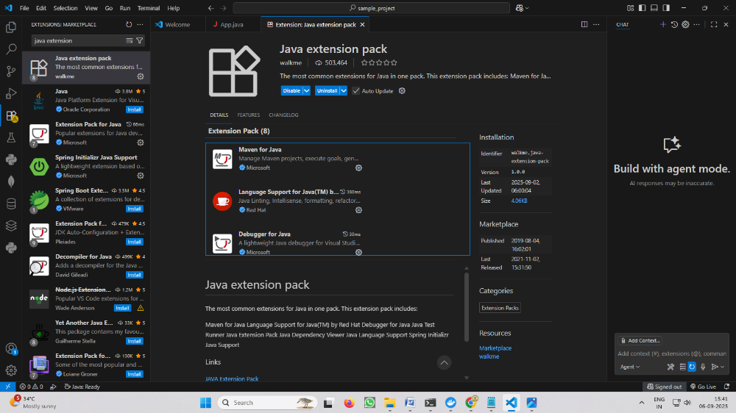

Write a simple test:
• Once you have your IDE set up, you can write a simple test using the Selenium
WebDriver. Here’s an example in Java:
How to Create Java Project:
Open Visual Studio code----->Ctrl+Shift+P--- --.> Java: Create Java Project

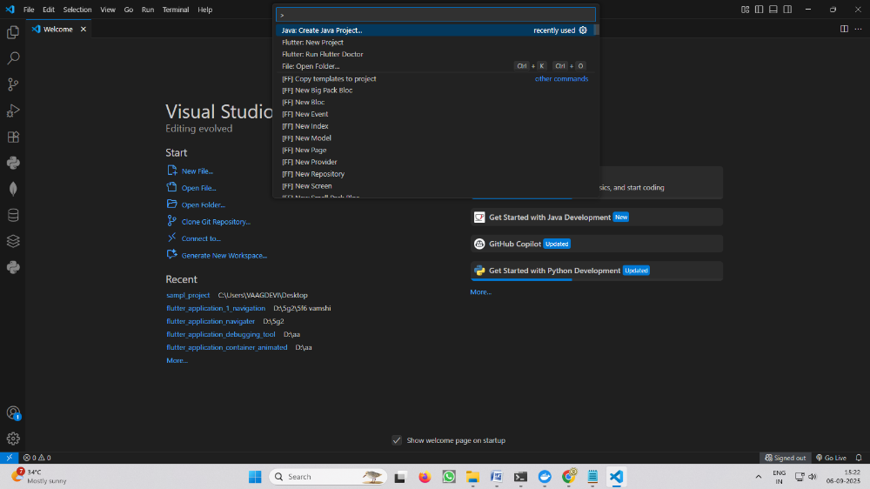

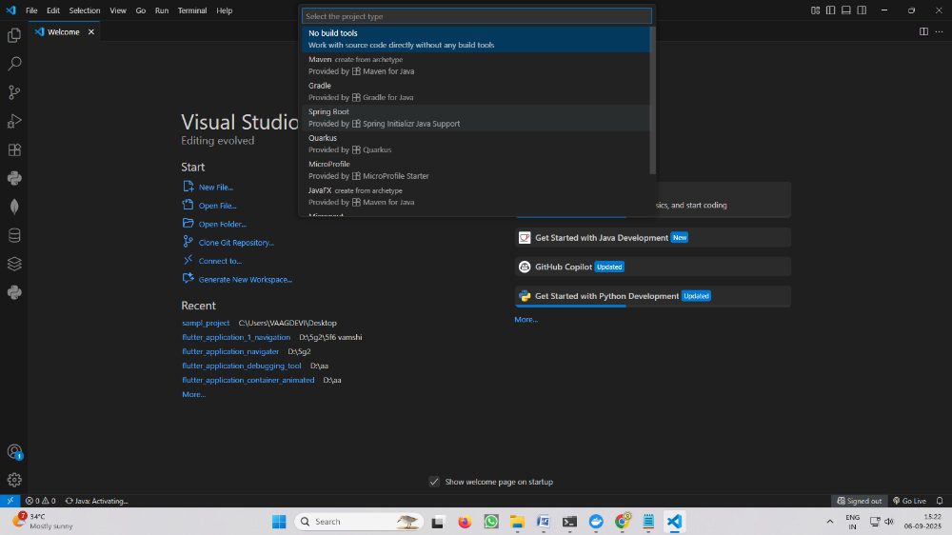

Give the Project Name: sample_project

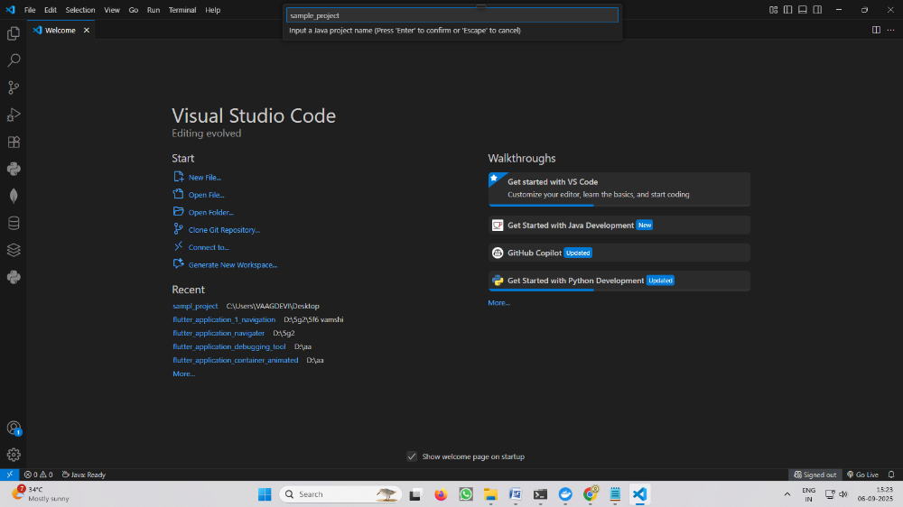

Go to selenium folder(Previously you unzip from selenium-java-4.48.0.zip ) and open the folder and copy the all Selenium Jar Libraries /files(Ctrl+A and Ctrl+C) to Lib folder(Ctrl+V) of inside sample_project folder.

Write the code in App.java

App.java

import org.openqa.selenium.WebDriver;
import org.openqa.selenium.firefox.FirefoxDriver;
public class App {
public static void main(String[] args) {

System.setProperty("webdriver.gecko.driver",
"/home/vaagdevi/Downloads/geckodriver");
WebDriver driver = new FirefoxDriver();
driver.get("https://www.vaagdevi.edu.in/");
System.out.println("Title: " + driver.getTitle());

driver.quit();
}
}
Open Visual Studio code Terminal and create a temporary profile:
sample_project$ mkdir -p ~/selenium-profile

sample_project$ export TMPDIR="$HOME/selenium-profile"

Run the test:
Run the test by using Run -Start Debugging (OR) F5

This is a basic example of how to get started with Selenium for automated testing. In a real-world scenario, you would likely write more complex tests and organize your code into test suites and test cases, but this example should give you a good starting point for exploring Selenium.


Experiment-11: Write a simple program in JavaScript and perform testing
using Selenium.
STEP 1: Create a Maven Project in VS Code
1. Open VS Code.
2. Press Ctrl+Shift+P to open the Command Palette.
3. Search for and select Maven: Create Maven Project.
4. Select archetype: maven-archetype-quickstart.
5. Select version: 1.4.
6. Enter Group ID: com.example
7. Enter Artifact ID: selenium-demo
8. Choose a folder to save the project and click Finish.
9. VS Code will generate the Maven project structure.
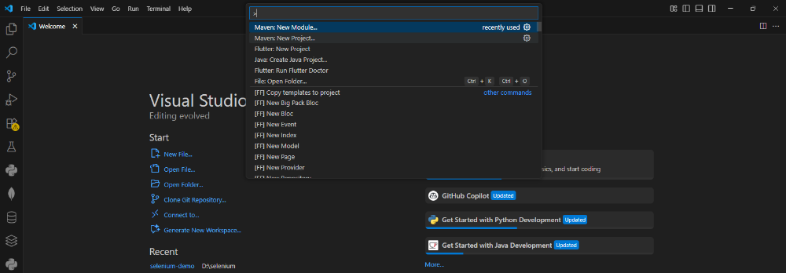

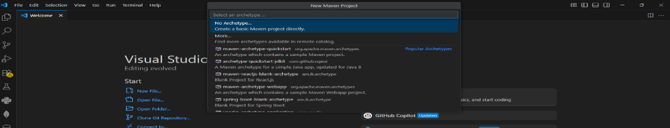

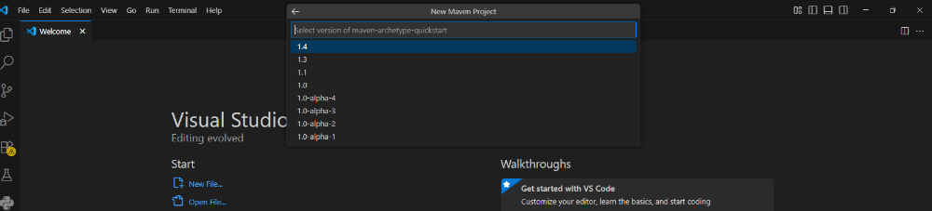
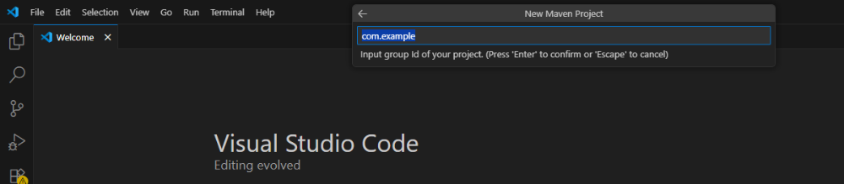

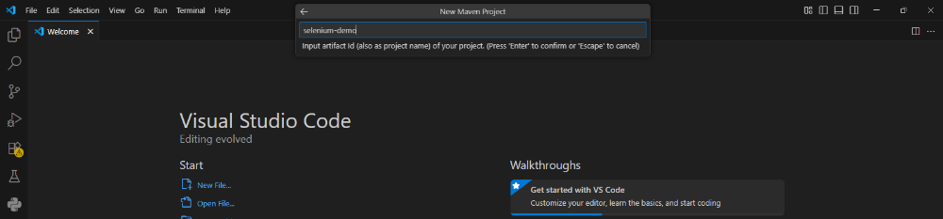

Project Structure:
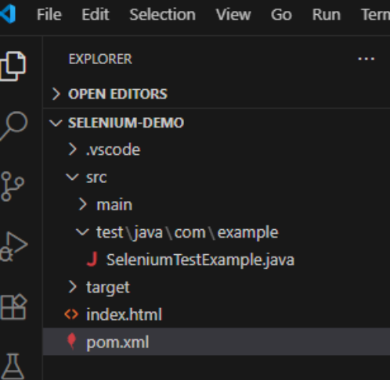

STEP 2: Add index.html File
1. In the root folder of your Maven project, create a new file named index.html.
2. Write the following HTML code into the file: index.html
<!DOCTYPE html>
<html>
<head>
<meta charset="utf-8">
<title>Simple JS Example</title>
</head>
<body>
<h1 id="heading">Original Heading</h1>
<button id="btn" onclick="changeText()">Click Me</button>
<script>
function changeText() {
document.getElementById("heading").innerText =
"Hello, Selenium!";
}
</script>
</body>
</html>
3.Save the file.

STEP 3: Create Selenium Test Class
1. In the Maven structure, navigate to: src/test/java/com/example/
2. Create a new Java file: SeleniumTestExample.java
SeleniumTestExample.java
package com.example;
import org.junit.jupiter.api.AfterAll;
import org.junit.jupiter.api.BeforeAll;
import org.junit.jupiter.api.Test;
import org.openqa.selenium.By;
import org.openqa.selenium.WebDriver;
import org.openqa.selenium.WebElement;
import org.openqa.selenium.firefox.FirefoxDriver;
import org.openqa.selenium.firefox.FirefoxOptions;
import org.openqa.selenium.firefox.GeckoDriverService;
import java.nio.file.Paths;
import static org.junit.jupiter.api.Assertions.assertEquals;

public class SeleniumTestExample {

static WebDriver driver;

@BeforeAll
static void setUp() {

System.setProperty(
"webdriver.gecko.driver",
"/home/vaagdevi/Downloads/geckodriver "
);
FirefoxOptions options = new FirefoxOptions();

driver = new FirefoxDriver(options);
}

@Test
void testButtonClickChangesHeading() {

String filePath =
Paths.get("index.html").toAbsolutePath().toUri().toString();

driver.get(filePath);

WebElement heading =
driver.findElement(By.id("heading"));

assertEquals(
"Original Heading",
heading.getText()
);

driver.findElement(By.id("btn")).click();

heading = driver.findElement(By.id("heading"));

assertEquals(
"Hello, Selenium!",
heading.getText()
);

System.out.println("Test Passed!");
}

@AfterAll
static void tearDown() {

if (driver != null) {
driver.quit();
}
}
}
STEP 4: Add Required Dependencies in pom.xml
In your Maven project, open the pom.xml file and add these dependencies:
pom.xml
<dependencies>

<!-- JUnit Jupiter (JUnit 5) -->
<dependency>
<groupId>org.junit.jupiter</groupId>
<artifactId>junit-jupiter</artifactId>
<version>5.10.2</version>
<scope>test</scope>
</dependency>

<!-- Selenium Java -->
<dependency>
<groupId>org.seleniumhq.selenium</groupId>
<artifactId>selenium-java</artifactId>
<version>4.48.0</version>
</dependency>

<!-- Simple Logging Facade for Java -->
<dependency>
<groupId>org.slf4j</groupId>
<artifactId>slf4j-simple</artifactId>
<version>2.0.17</version>
<scope>test</scope>
</dependency>

</dependencies>

STEP 5: Run the Selenium Test
1. Open the Terminal in VS Code.
2. Navigate to your Maven project folder (if not already there).
3. Run the following command: mvn test
You should see output indicating that the test ran and passed.
✅ It will open Chrome, load your index.html, click the button, and verify
the heading changes to: "Hello, Selenium!"

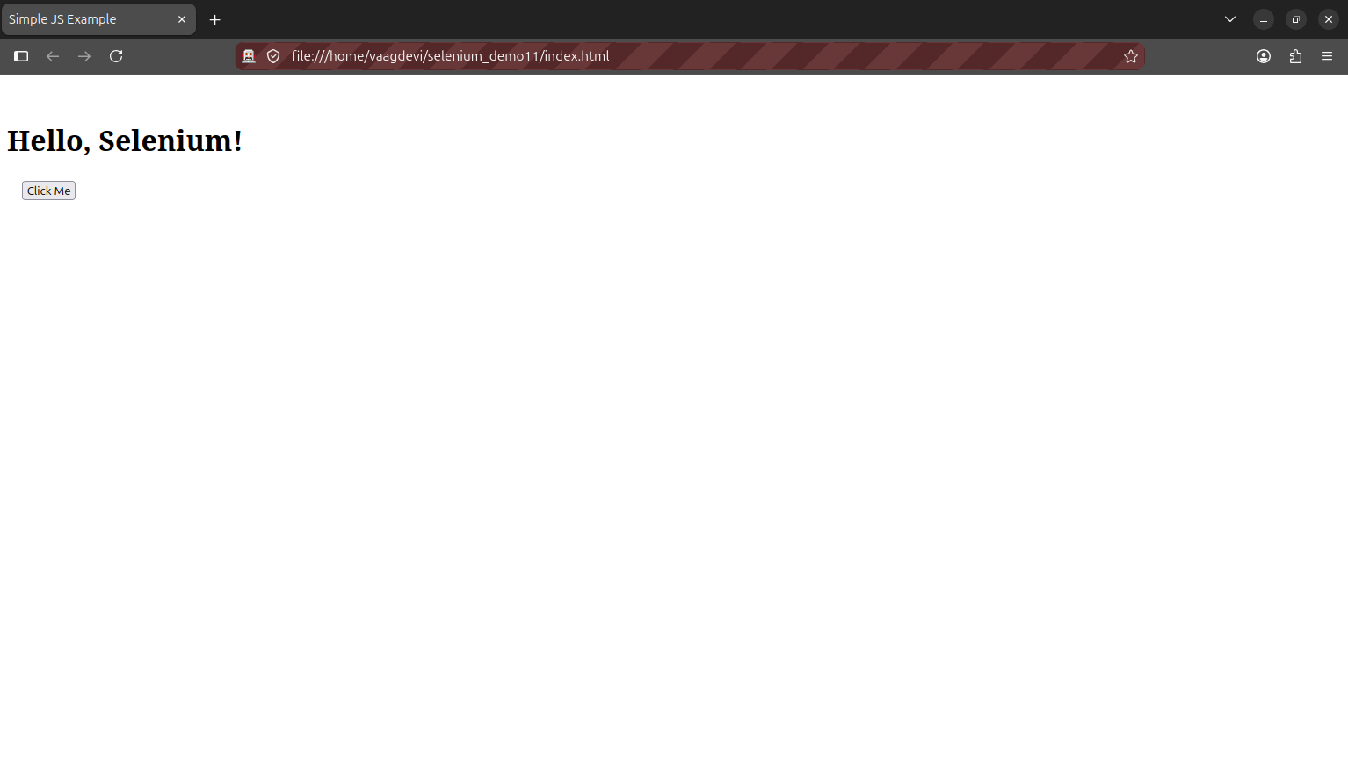

Experiment-12: Develop test cases for the above containerized application using selenium.

STEP 1: Create a Maven Project in VS Code
1. Open VS Code.
2. Press Ctrl+Shift+P to open the Command Palette.
3. Search for and select Maven: Create Maven Project.
4. Select archetype: maven-archetype-quickstart.
5. Select version: 1.4.
6. Enter Group ID: com.registration
7. Enter Artifact ID: registration-test
8. Choose a folder to save the project and click Finish.
9. VS Code will generate the Maven project structure.
registration-test/
├── src/
│ ├── main/java/com/registration/App.java
│ └── test/java/com/registration/AppTest.java
├── pom.xml

STEP 2: Replace the pom.xml with Dependencies for Selenium
Replace the contents of pom.xml with the following:

<?xml version="1.0" encoding="UTF-8"?>

<project xmlns="http://maven.apache.org/POM/4.0.0"
xmlns:xsi="http://www.w3.org/2001/XMLSchema-instance"
xsi:schemaLocation="http://maven.apache.org/POM/4.0.0
http://maven.apache.org/xsd/maven-4.0.0.xsd">

<modelVersion>4.0.0</modelVersion>

<groupId>com.registration</groupId>
<artifactId>selenium-demo</artifactId>
<version>1.0-SNAPSHOT</version>

<properties>
<!-- Java -->
<maven.compiler.source>21</maven.compiler.source>
<maven.compiler.target>21</maven.compiler.target>

<!-- JUnit -->
<junit.jupiter.version>5.10.2</junit.jupiter.version>

<!-- Selenium -->
<selenium.version>4.48.0</selenium.version>
</properties>

<dependencies>

<!-- Selenium -->
<dependency>
<groupId>org.seleniumhq.selenium</groupId>
<artifactId>selenium-java</artifactId>
<version>${selenium.version}</version>
</dependency>

<!-- JUnit Jupiter -->
<dependency>
<groupId>org.junit.jupiter</groupId>
<artifactId>junit-jupiter</artifactId>
<version>${junit.jupiter.version}</version>
<scope>test</scope>
</dependency>

</dependencies>

<build>
<plugins>

<plugin>
<groupId>org.apache.maven.plugins</groupId>
<artifactId>maven-compiler-plugin</artifactId>
<version>3.8.0</version>
<configuration>
<source>21</source>
<target>21</target>
</configuration>
</plugin>

<plugin>
<groupId>org.apache.maven.plugins</groupId>
<artifactId>maven-surefire-plugin</artifactId>
<version>3.2.5</version>
<configuration>
<useModulePath>false</useModulePath>
</configuration>
</plugin>

</plugins>
</build>

</project>

STEP 3: Update the Test Class
AppTest.java
package com.example;

import org.junit.jupiter.api.AfterAll;
import org.junit.jupiter.api.BeforeAll;
import org.junit.jupiter.api.Test;
import org.openqa.selenium.By;
import org.openqa.selenium.WebDriver;
import org.openqa.selenium.WebElement;
import org.openqa.selenium.firefox.FirefoxDriver;
import org.openqa.selenium.firefox.FirefoxOptions;

import static org.junit.jupiter.api.Assertions.assertTrue;

public class AppTest {

static WebDriver driver;

@BeforeAll
static void setUp() {

System.setProperty(
"webdriver.gecko.driver",
"/home/Vaagdevi/Downloads/geckodriver"
);

FirefoxOptions options = new FirefoxOptions();

driver = new FirefoxDriver(options);
}

@Test
void testFormSubmission() {

driver.get("http://localhost:8080");

driver.findElement(By.id("name"))
.sendKeys("vinay");

driver.findElement(By.id("email"))
.sendKeys("vinay@gmail.com");

driver.findElement(By.id("phone"))
.sendKeys("1234567890");

WebElement gender = driver.findElement(By.id("gender"));
gender.sendKeys("Male");

WebElement event = driver.findElement(By.id("event"));
event.sendKeys("coding contest");

driver.findElement(
By.cssSelector("button[type='submit']")
).click();

assertTrue(
driver.getPageSource().contains("Event Registration")
);

System.out.println("Test Passed!");
}

@AfterAll
static void tearDown() {

if (driver != null) {
driver.quit();
}
}
}

STEP 4: Update the HTML (index.html) File
Make sure your index.html inside the Docker project contains this corrected version:

<!DOCTYPE html>
<html lang="en">
<head>
<meta charset="UTF-8">
<meta name="viewport" content="width=device-width, initial-scale=1.0">
<title>Event Registration</title>
</head>
<body>

<form action="submit" method="POST">

<h2>Event Registration</h2>

<label for="name">Full Name</label>
<input type="text" id="name" name="name" required>
<br>

<label for="email">Email Address</label>
<input type="email" id="email" name="email" required>
<br>

<label for="phone">Phone Number</label>
<input type="tel" id="phone" name="phone" required>
<br>

<label for="gender">Gender</label>
<select id="gender" name="gender">
<option value="Male">Male</option>
<option value="Female">Female</option>
<option value="Other">Other</option>
</select>

<br>

<label for="event">Choose Event</label>
<select id="event" name="event">
<option value="coding">Coding Contest</option>
<option value="debate">Debate</option>
<option value="music">Music Show</option>
</select>

<br>

<button type="submit">Register</button>

</form>

</body>
</html>

STEP 5: Rebuild and Run the Docker Container
In the folder containing your Dockerfile and index.html:
$ docker build -t registration-form .
$ docker run -dp 8080:80 registration-form
Make sure it's accessible at:
➡ http://localhost:8080
STEP 6: Run the Selenium Test
In VS Code terminal or command prompt: mvn test

